SCHOOL OF COMPUTER SCIENCE

**MACHINE LEARNING**

BACHELOR OF COMPUTER SCIENCE ENGINEERING WITH SPECIALIZATION IN ARTIFICIAL INTELLIGENCE AND MACHINE LEARNING

BATCH: B3 (Hons.)

SEMESTER: IV

SUBMITTED TO: PROF. GOPAL S PHARTIYAL

SUBMITTED BY: HARSHIT RAHEJA and HARSH GOYAL

SAP ID: 500086226, 500086197

ROLL NO: R2142201556, R2142201617

**ASSIGNMENT 2: PROJECT ANALYSIS OF IPL MATCHES**

**Procedure:**

Step1: Download the zip File.

Step 2: Change the path of the csv files to the path you have stored the csv files.

Step 3: Analysis is done on the basis of various graphs

**Code:**

#%%

# importing all the libraries

import pandas as pd

import numpy as np

import matplotlib.pyplot as plt

import seaborn as sns

import warnings

#%%

# calling the dataset

warnings.filterwarnings('ignore')

data = pd.read_csv("D:\ML project\matches.csv") #change the path

data.head(3)

#%%

#calling the dataset

Data = pd.read_csv("D:\ML project\deliveries.csv") #change the path

Data.head(3)

#%%

season_data=data[['id','season','winner']]

complete_data=Data.merge(season_data,how='inner',left_on='match_id',right_on='id')

data.columns.values

#%%

data = data.drop(columns=["umpire3"],axis=1)

data.head(3)

#%%

winner_per_season = data.groupby("season")["winner"].value_counts()

winner_per_season

#%%

#number of matches played per IPL season

plt.figure(figsize = (20,15))

sns.countplot('season',data=data,palette="tab10")

plt.title("Number of Matches played per IPL Season",fontsize=30)

plt.xlabel("Season",fontsize=20)

plt.xticks(fontsize=15)

plt.yticks(fontsize=15)

plt.ylabel('Matches',fontsize=20)

plt.show()

#%%

#Match wins by team

plt.figure(figsize = (20,15))

sns.countplot(x='winner',data=data, palette='crest')

plt.title("Match wins by team ",fontsize=30)

plt.xticks(fontsize=15,rotation=90)

plt.yticks(fontsize=15)

plt.xlabel("Teams",fontsize=20)

plt.ylabel("No of wins",fontsize=20)

plt.show()

#%%

data['win_by']=np.where(data['win_by_runs']>0,'Bat first','Bowl first')

#%%

#match results who bowl first and win the match

Win=data.win_by.value_counts()

labels=np.array(Win.index)

sizes = Win.values

colors = ['red', 'orange']

plt.figure(figsize = (10,10))

plt.pie(sizes, labels=labels, colors=colors,autopct='%1.1f%%', shadow=True,startangle=90)

plt.title('Match Results',fontsize=30)

plt.axis('equal')

plt.show()

#%%

#Match wins by batting and bowling

plt.figure(figsize = (20,10))

sns.countplot('season',hue='win_by',data=data,palette='husl')

plt.title("Match wins by batting and bowling ",fontsize=30)

plt.xticks(fontsize=15)

plt.yticks(fontsize=15)

plt.xlabel("Season",fontsize=20)

plt.ylabel("Count",fontsize=20)

plt.show()

#%%

#Toss result

Toss=data.toss_decision.value_counts()

labels=np.array(Toss.index)

sizes = Toss.values

colors = ['cyan', 'pink']

plt.figure(figsize = (10,10))

plt.pie(sizes, labels=labels, colors=colors,autopct='%1.1f%%', shadow=True,startangle=90)

plt.title('Toss result',fontsize=30)

plt.axis('equal')

plt.show()

#%%

# match win by toss result

plt.figure(figsize = (20,10))

sns.countplot('season',hue='toss_decision',data=data,palette='rocket')

plt.title("Match win by Toss result ",fontsize=30)

plt.xlabel("Season",fontsize=20)

plt.ylabel("Count",fontsize=20)

plt.xticks(fontsize=15)

plt.yticks(fontsize=15)

plt.show()

#%%

#final matches

final_matches=data.drop_duplicates(subset=['season'], keep='last')

final_matches[['season','winner']].reset_index(drop=True).sort_values('season')

#%%

#match result

match = final_matches.win_by.value_counts()

labels=np.array(Toss.index)

sizes = match.values

colors = ['purple', 'white']

plt.figure(figsize = (10,10))

plt.pie(sizes, labels=labels, colors=colors, autopct='%1.1f%%', shadow=True,startangle=90)

plt.title('Match Result',fontsize=30)

plt.axis('equal')

plt.show()

#%%

#top player of the match winners

top_players = data.player_of_match.value_counts()[:15]

fig, ax = plt.subplots()

ax.set_ylim([0,25])

ax.set_xlim([0,20])

ax.set_ylabel("Count",fontsize=20)

ax.set_xlabel("Player_Name",fontsize=20)

ax.set_title("Top player of the match winners",fontsize=30)

plt.xticks(fontsize=15)

plt.yticks(fontsize=15)

top_players.plot.bar(figsize = (20,15))

sns.barplot(x = top_players.index, y = top_players, orient='v', palette="Spectral");

plt.show()

#%%

# fours hits by players

four_data=complete_data[complete_data['batsman_runs']==4]

four_data.groupby('batting_team')['batsman_runs'].agg([('runs by fours','sum'),('fours','count')])

batsman_four=four_data.groupby('batsman')['batsman_runs'].agg([('four','count')]).reset_index().sort_values('four',ascending=0)

ax=batsman_four.iloc[:15,:].plot('batsman','four',kind='bar',color='gold',figsize = (20,15))

ax.set_title("Fours hit by playes ",fontsize=30)

plt.xticks(rotation=90)

plt.xlabel("Player name",fontsize=20)

plt.ylabel("No of fours",fontsize=20)

plt.xticks(fontsize=15)

plt.yticks(fontsize=15)

plt.show()

#%%

#six hits by players

six_data=complete_data[complete_data['batsman_runs']==6]

six_data.groupby('batting_team')['batsman_runs'].agg([('runs by six','sum'),('sixes','count')])

batsman_six=six_data.groupby('batsman')['batsman_runs'].agg([('six','count')]).reset_index().sort_values('six',ascending=0)

ax=batsman_six.iloc[:15,:].plot('batsman','six',kind='bar',color='lime',figsize = (20,15))

plt.title("Six hit by playes ",fontsize=30)

plt.xticks(fontsize=15)

plt.yticks(fontsize=15)

plt.xlabel("Player name",fontsize=20)

plt.ylabel("No of six",fontsize=20)

plt.show()

#%%

#Dismissals

plt.figure(figsize=(20,15))

ax=sns.countplot(Data.dismissal_kind,palette="terrain")

plt.title("Dismissals",fontsize=30)

plt.xlabel("Dismissals type",fontsize=20)

plt.ylabel("count",fontsize=20)

plt.xticks(fontsize=15)

plt.yticks(fontsize=15)

plt.show()

**Output:**

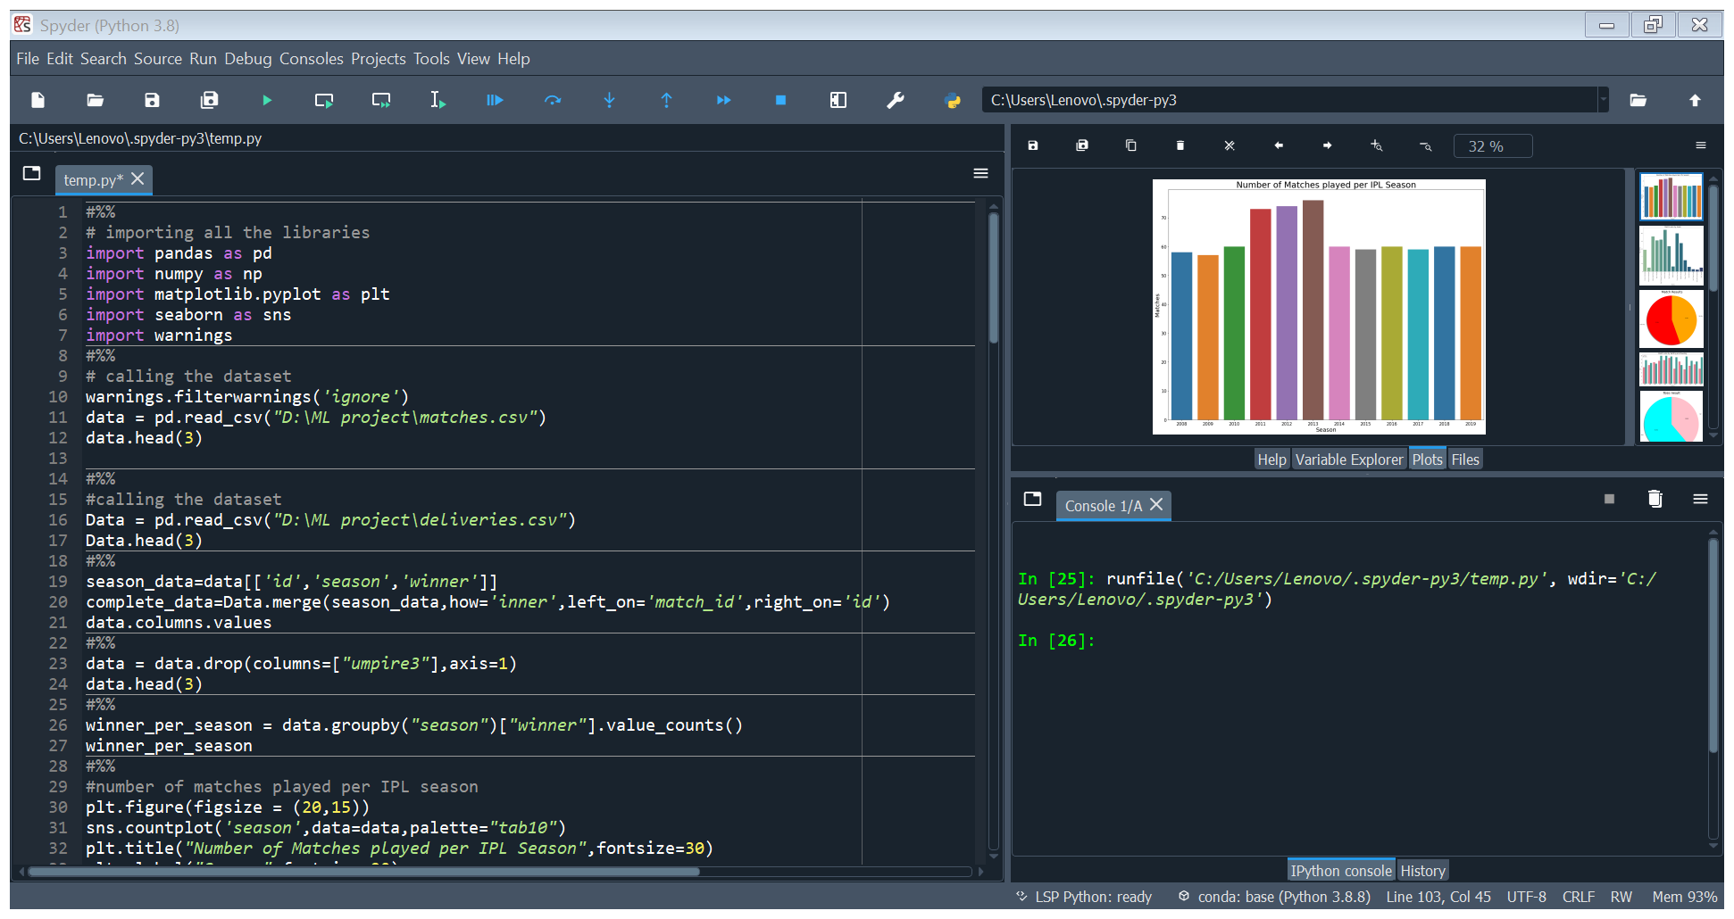

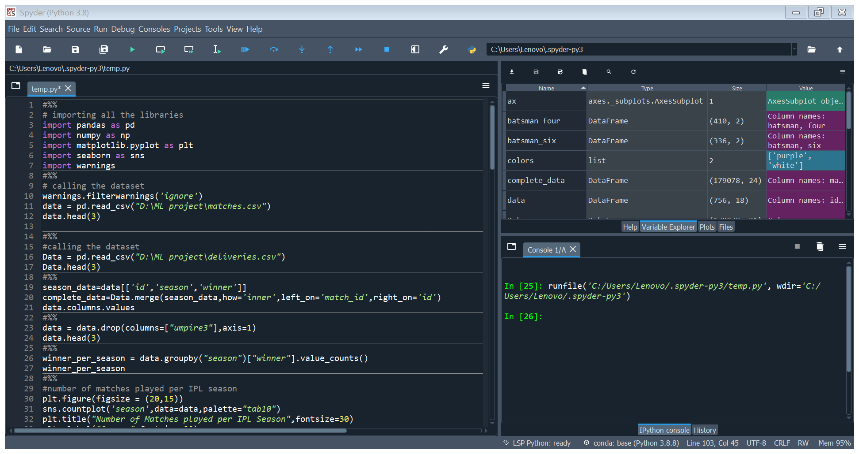

**Output of Graphs and codes:**

